Examination System DB Documentation

DB Tables

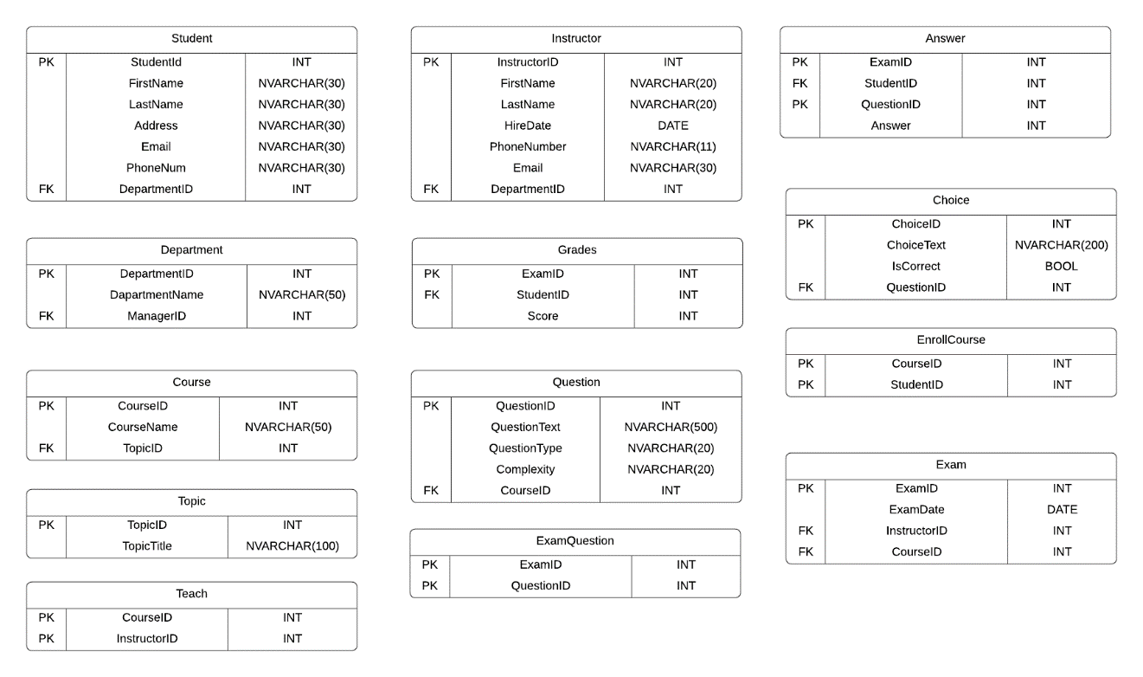

DB Mapping

